Juices
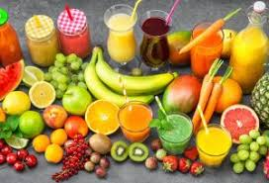
coca-cola
- Cool Kiwi Juice – Rupes 50
- Aam Ras - Rupes 30
- Ananas Da Panna – Rupes 40
- Lychee And Dill Juice– Rupes 70
- Very Berry Khatta– Rupes 20
- Virgin Punch– Rupes 20
- Grape Nectar– Rupes 40
Breakfast
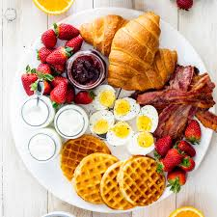

- Fruity Panckes – Rupes 598
- French Slam– Rupes 589
- Toast – Rupes 200
- Hoat-Dog – Rupes 80
- Ccoffe – Rupes 30
- Tea – Rupes 20
- Poha – Rupes 50
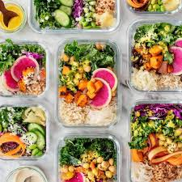
Lunch

- Gujarati Kadhi.
- Chana Kulcha.
- Allahabad Ki Tehri.
- Kolhapuri Vegetables.
- Black Channa And Coconut Stew.
- Paneer Achaari.
- Piza
- Buger
- Pasta

Evening snaks
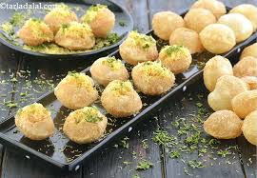

- Mixed Nuts.
- Red Bell Pepper With Guacamole. ...
- Greek Yogurt And Mixed Berries.
- Apple Slices With Peanut Butter.
- Cottage Cheese With Flax Seeds And Cinnamon.
- Celery Sticks With Cream Cheese.
- Kale Chips
- Dark Chocolate & Almonds.
- Gol-Gape
Dinner
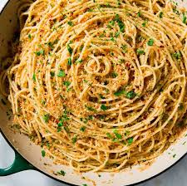
- Paneer Butter Masala/ Paneer Makhani.
- Paneer Tikka Masala.
- Saag Paneer/ Palak Paneer.
- Kadai Paneer.
- Matar Paneer.
- Vegetable Korma.
- Aloo Gobi Cauliflower With Potatoes.
- Momos
Desserts
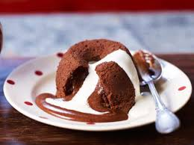
- Lucky Charms Cheesecake. ...

- Lucky Charms Cheesecake. ...
- Candy
- confection.
- cookie.
- Ice cream.
- Cherpumple.

Name- Shivansh Thakur
Rollno- 29
class- 4E

